1. **Let’s** try to understand the psychology behind the development of Shooting Star Candlestick pattern.
2. 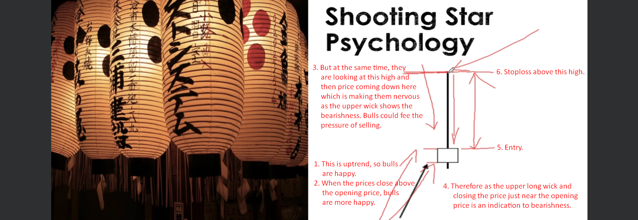
3. 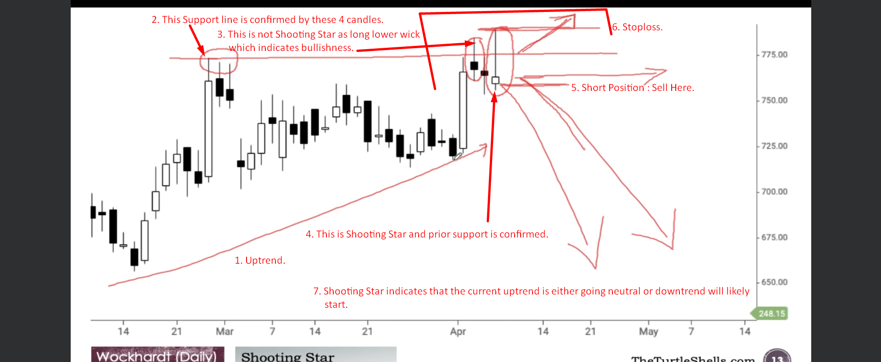
4. 